**REPORT ON SALES OF AUTOS**

**ANALYSIS-3**

2) What is the Average price of vehicle by fuel type and gearbox type. Give a plot

To show the average price of vehicles based on the fuel type and gear type we should use bar plot for this heat map.

To collect the average prices of both the fuel type and gear box,

We can use pivort table by using it, we can take index as gear box, columns are fuel type and values as price, pivort table default take the average of price.

Code for pivort table:

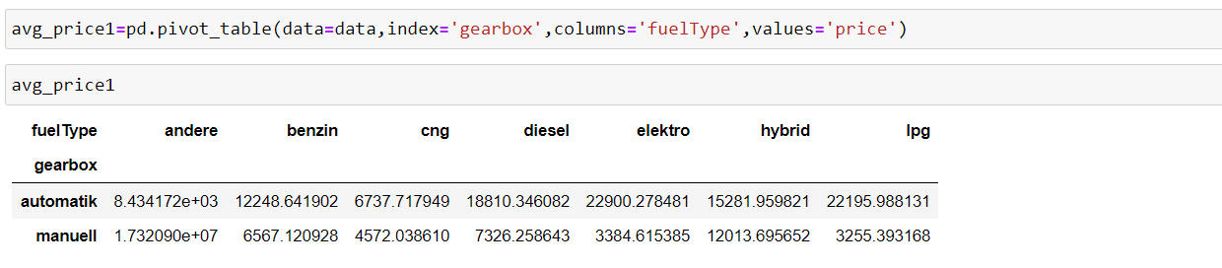

Here shows that the all average prices about the combination of fuel type and gearbox.

Code for bar plot:

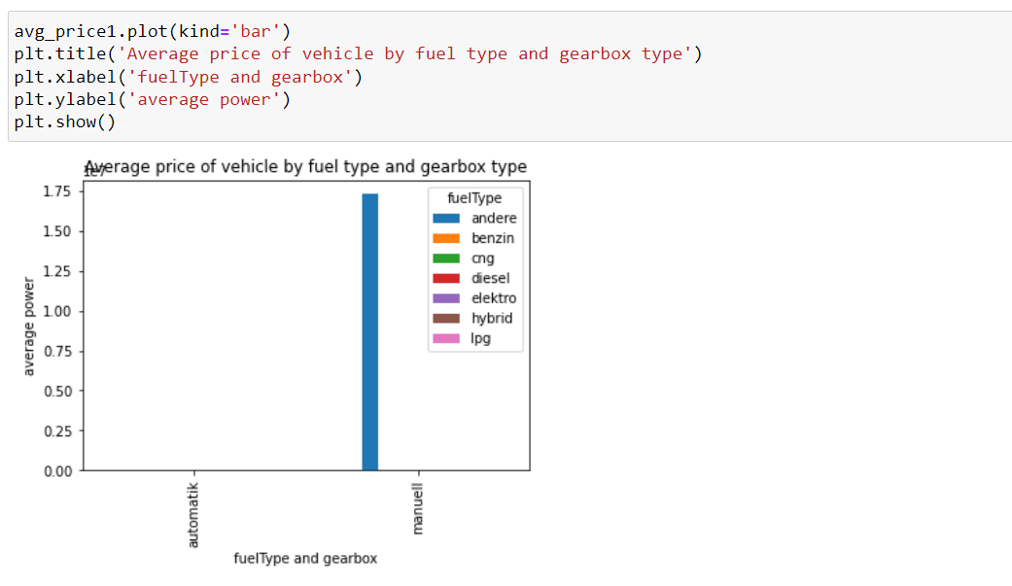

From the bar plot we can say that :

The fuel name containing andere and gearbox as manuell has the highest average price among all the vehicle combinations of fuel type and gear box.

Due to the outlier in the fuel type the average price is effected so that the only one bar is at the highest and all other are lower.

By heat map also we can represent the average price of vehicles based on the fuel type and gear box.

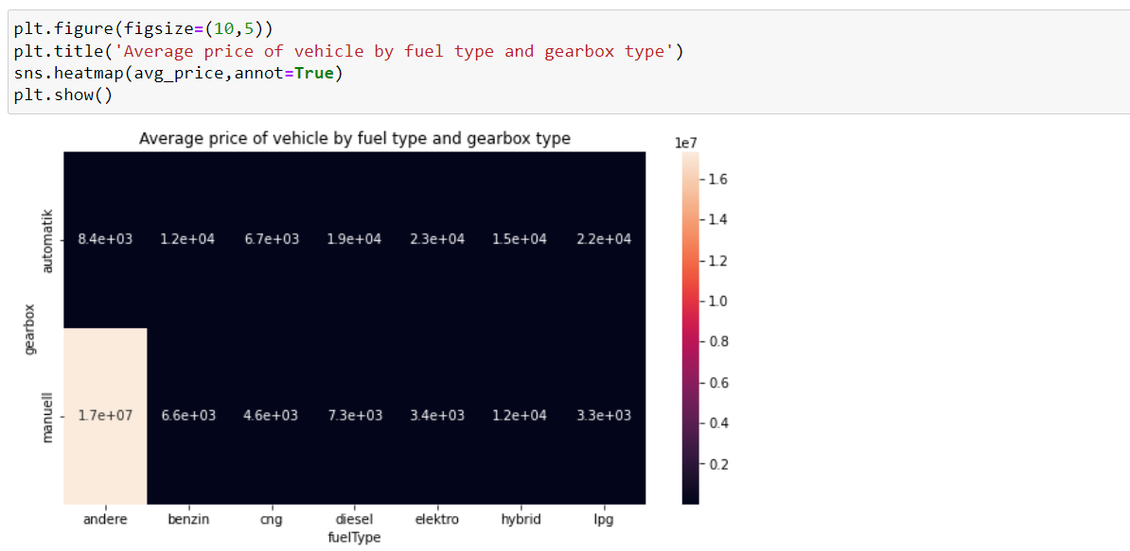

By color difference we can define the plot.

The fuel name containing andere and gearbox as manuell has the highest average price among all the vehicle combinations of fuel type and gear box.

3) What is the Average power of a vehicle by vehicle type and gearbox type. Give a plot

To show the average power of vehicles based on the vehicle type and gear type we should use bar plot and heatmap.

To collect the average power of both the vehicle type and gear box at a time

We can use pivort table by using it, we can take index as gear box, columns are vehicle type and values as price, pivort table default take the average of power.

Code for pivort table:

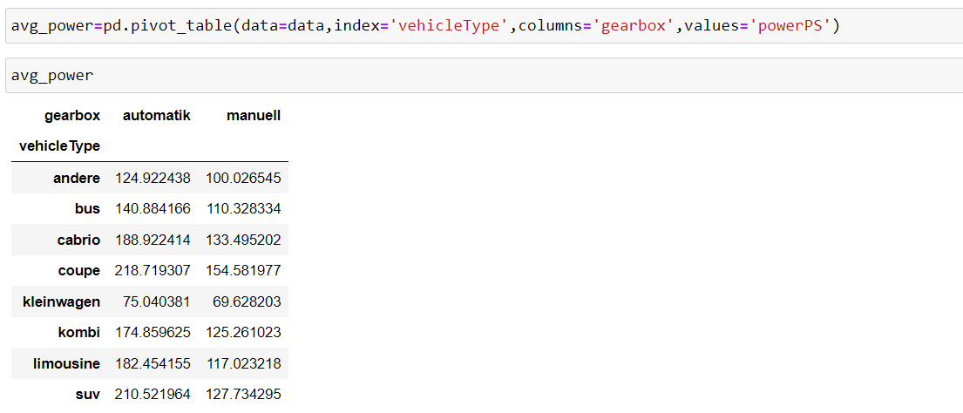

Here shows that the all average power about the combination of fuel type and gearbox.

Code for bar plot:

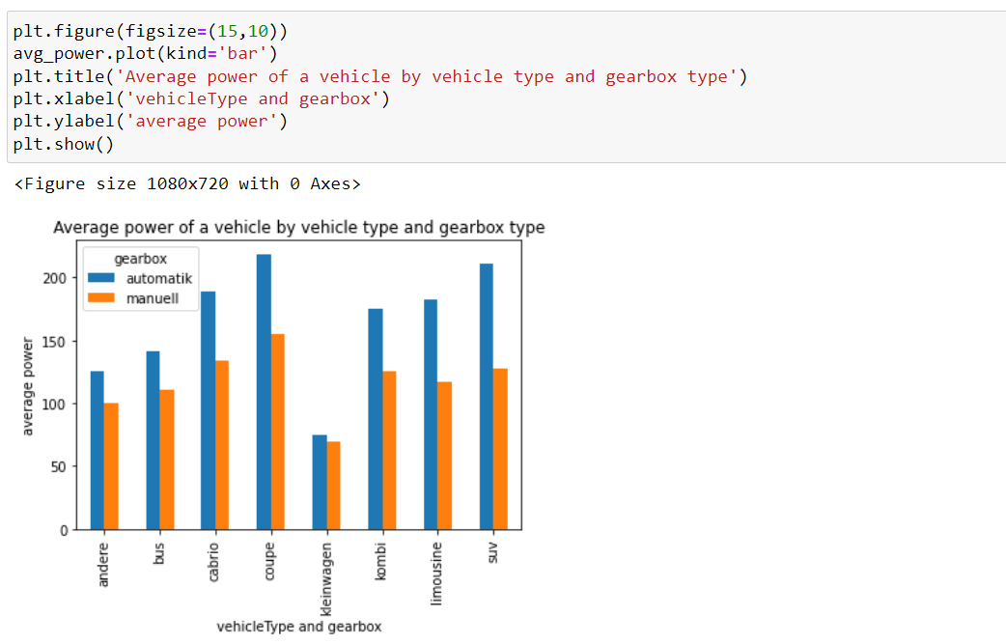

From the bar plot we can say that:

The vehicle name containing coupe and gearbox as automatik has the highest average power of 230 among all the vehicle combinations of vehicle type and gear box. These bar plot gives us all the combination of all the vehicle type and gear box type average powers.

By heat map also we can represent the average price of vehicles based on the fuel type and gear box.

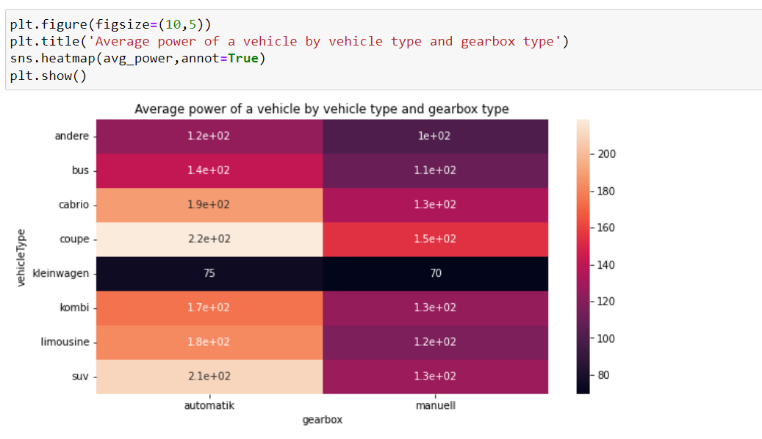

By color difference we can define the plot.

Here shows that the all average power about the combination of vehicletype and gearbox

The vehicle name containing coupe and gearbox as automatik has the highest average power of 230 among all the vehicle combinations of vehicle type and gear box.

4) What is the Average price of a vehicle by brand as well as vehicle type.Use heatmap to explain this

To show the average price of vehicles based on the vehicle type and brand by using heatmap plot for this

To collect the average prices of both the vehicle type and brand at a time,

We can use pivort table by using it, we can take index as gear box, columns are vehicle type and values as price, pivort table default take the average of power.

Code for pivort table:

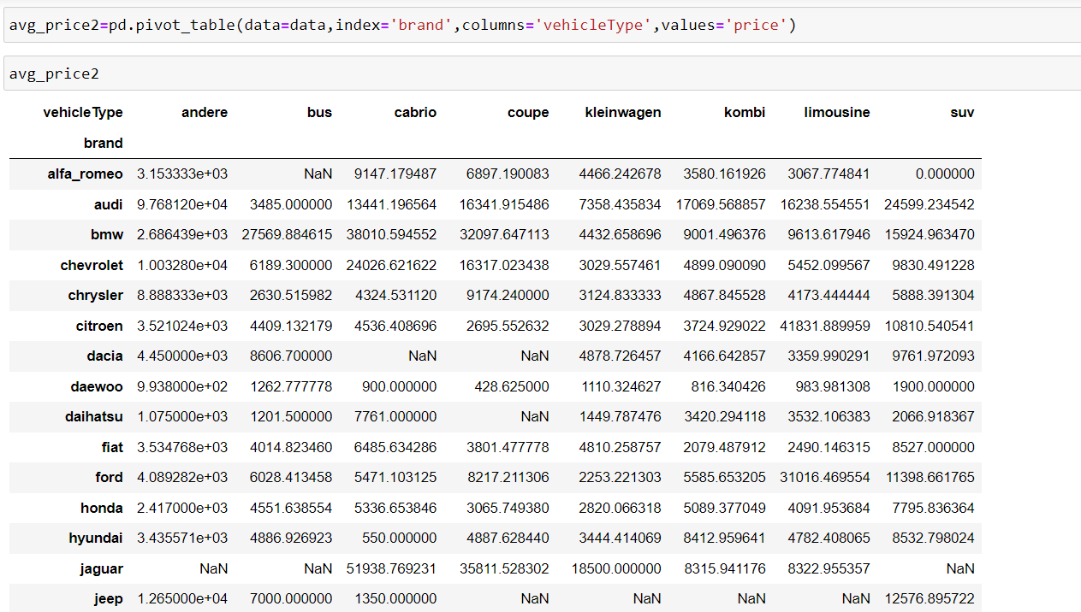

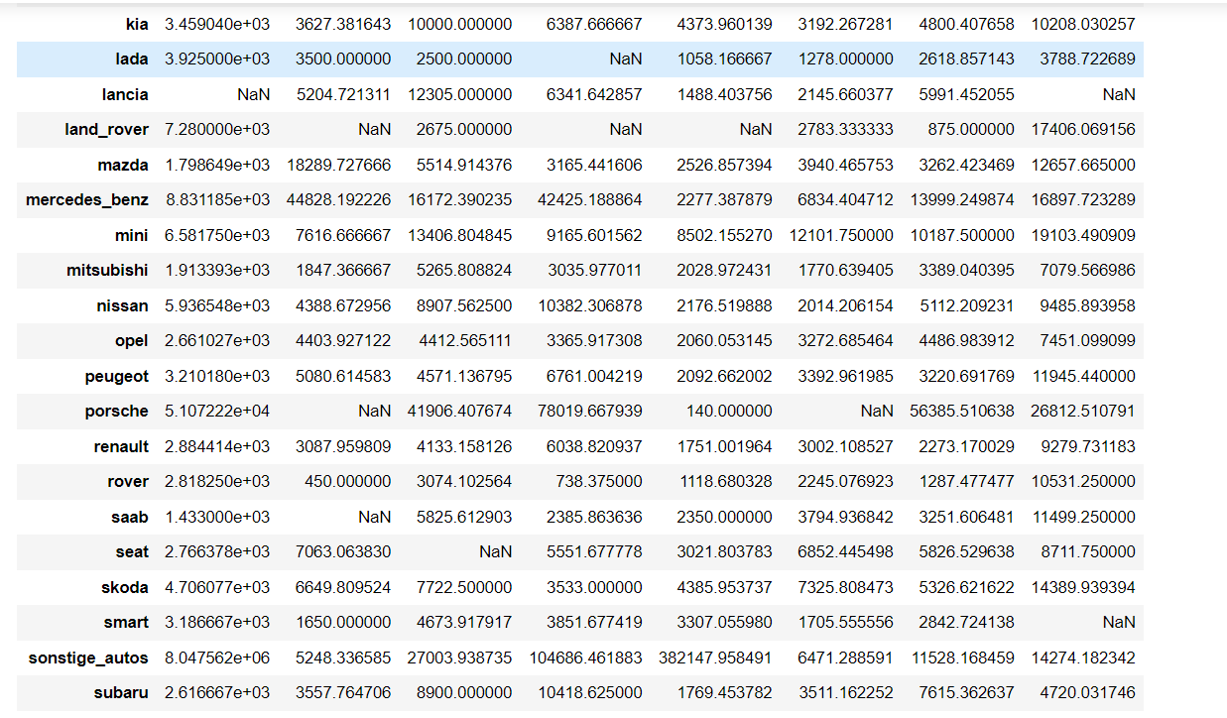

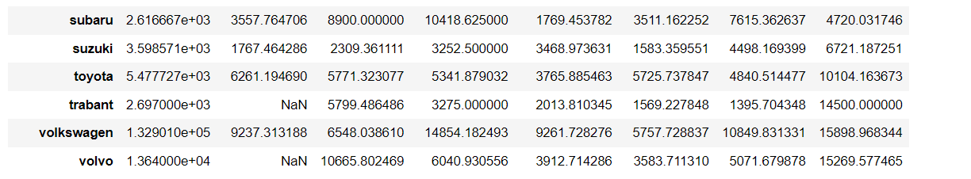

This above picture shows you the average prices of all the brand and vehicle types as well at a time.

Code for heatmap:

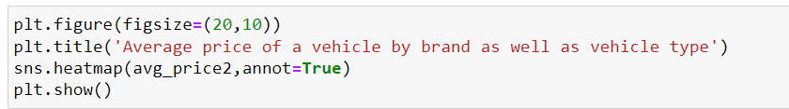

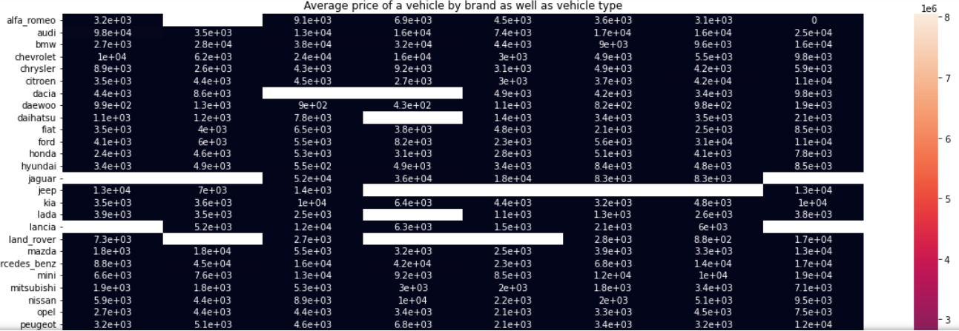

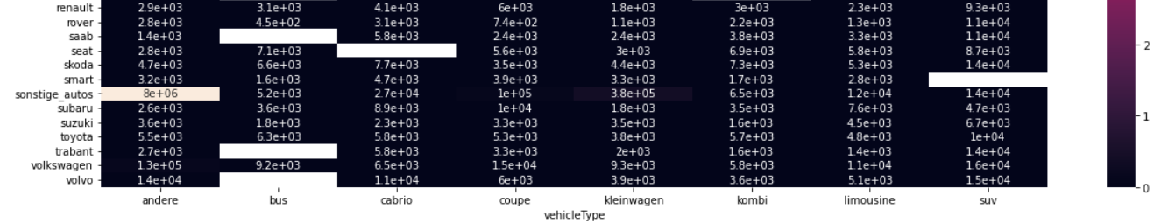

Here the image of heatmap shows that the all values of average prices for the vehicle type and brand at a time